**OOP Lab09 – Small Business Pt 2 (Inventory Manager)**

**Note: This lab uses the Item and Inventory classes you wrote in the last lab. Do not change those classes for this lab! You’ll simply be writing an InventoryRunner program that uses the classes you wrote previously.**

**Write a user interface for your inventory management system.**

Call your class InventoryRunner. It should be similar to InventoryTester, except that it provides the ability for the user to add and sell items.

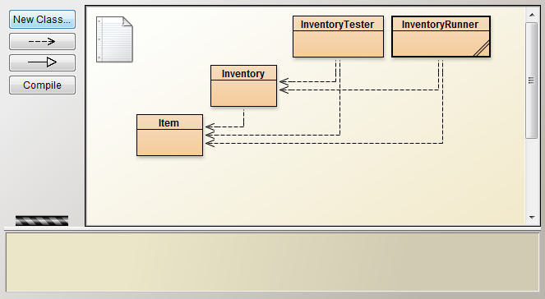

Video of what the user interface should look like: <https://youtu.be/hMY7Qft_hwo>

Test your program with this plan, which is also used in the video:

1. Add a new item (a goldfish bowl, valued at $6.23, listed on 4/8/17) to inventory spot 2.
2. *Attempt* to add a different item (whatever you want) into inventory spot 2. It should refuse.
3. Add a new item (old mattress, valued at $12.52, listed on 4/10/17) to inventory spot 1.
4. Add a new item (case of salsa, valued at $299.99, listed on 5/1/17) to inventory spot 3.
5. Find the net value of all your inventory.
6. Attempt to add a new item to inventory. It should refuse immediately since you have no room in the garage.
7. You make a sale! Remove the goldfish bowl from your inventory.
8. That’s all for now. You can quit.

Sample Output on next page

Sample Output (user input in red)

Current inventory:

NO ITEM

NO ITEM

NO ITEM

(1) Add item to inventory.

(2) Remove sold item from inventory.

(3) Get net worth of inventory

(4) Quit

What would you like to do? (1-4) >>> **1**

New item name/description >>> **a goldfish bowl**

New item cost >>> $**6.23**

New item date of listing >>> **4/8/17**

Where in the garage will you store this? (1-3) >>> **2**

Current inventory:

NO ITEM

a goldfish bowl, $6.23 (Listed: 5/5/17)

NO ITEM

(1) Add item to inventory.

(2) Remove sold item from inventory.

(3) Get net worth of inventory

(4) Quit

What would you like to do? (1-4) >>> **1**

New item name/description >>> **some junk**

New item cost >>> $**23**

New item date of listing >>> **4/9/17**

Where in the garage will you store this? (1-3) >>> **2**

Can't add item to that itemNumber. Currently occupied.

Current inventory:

NO ITEM

a goldfish bowl, $6.23 (Listed: 5/5/17)

NO ITEM

(1) Add item to inventory.

(2) Remove sold item from inventory.

(3) Get net worth of inventory

(4) Quit

What would you like to do? (1-4) >>> **1**

New item name/description >>> **a soiled mattress**

New item cost >>> $**12.52**

New item date of listing >>> **4/10/17**

Where in the garage will you store this? (1-3) >>> **1**

Current inventory:

a soiled mattress, $12.99 (Listed: 4/15/17)

a goldfish bowl, $6.23 (Listed: 5/5/17)

NO ITEM

(1) Add item to inventory.

(2) Remove sold item from inventory.

(3) Get net worth of inventory

(4) Quit

What would you like to do? (1-4) >>> **1**

New item name/description >>> **case of salsa**

New item cost >>> $**299.99**

New item date of listing >>> **5/1/17**

Where in the garage will you store this? (1-3) >>> **3**

Current inventory:

old mattress, $12.52 (Listed: 4/10/17)

a goldfish bowl, $6.23 (Listed: 4/8/17)

case of salsa, $299.99 (Listed: 5/1/17)

(1) Add item to inventory. (UNAVAILABLE. INVENTORY FULL.)

(2) Remove sold item from inventory.

(3) Get net worth of inventory

(4) Quit

What would you like to do? (1-4) >>> **3**

Net worth of inventory >>> $318.74

Current inventory:

old mattress, $12.52 (Listed: 4/10/17)

a goldfish bowl, $6.23 (Listed: 4/8/17)

case of salsa, $299.99 (Listed: 5/1/17)

(1) Add item to inventory. (UNAVAILABLE. INVENTORY FULL.)

(2) Remove sold item from inventory.

(3) Get net worth of inventory

(4) Quit

What would you like to do? (1-4) >>> **1**

Can't add item. Inventory is full.

Current inventory:

Old mattress, $12.52 (Listed: 4/10/17)

a goldfish bowl, $6.23 (Listed: 4/8/17)

case of salsa, $299.99 (Listed: 5/1/17)

(1) Add item to inventory.

(2) Remove sold item from inventory.

(3) Get net worth of inventory

(4) Quit

What would you like to do? (1-4) >>> **2**

Which item did you sell? (1-3) >>> **2**

Item from spot 2 is now gone.

Current inventory:

old mattress, $12.52 (Listed: 4/10/17)

NO ITEM

case of salsa, $299.99 (Listed: 5/1/17)

(1) Add item to inventory. (UNAVAILABLE. INVENTORY FULL.)

(2) Remove sold item from inventory.

(3) Get net worth of inventory

(4) Quit

What would you like to do? (1-4) >>> **4**